Cross Region Replication (CRR)
- First create two bucket in different different region, eg first create one bucket in Mumbai region and 2nd bucket Singapore region.
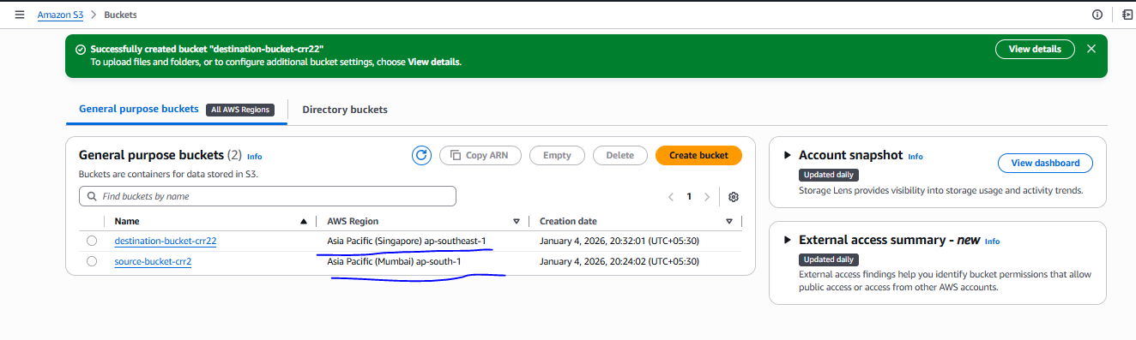
- Create a CRR in management section in source bucket
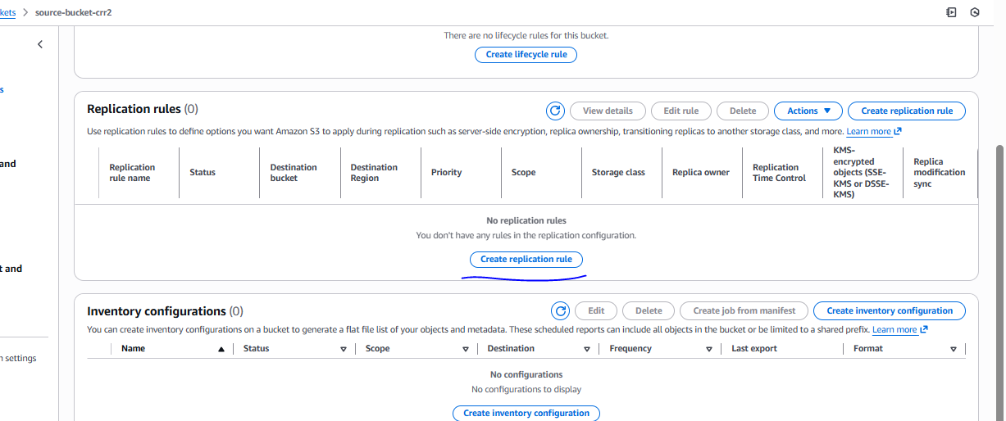
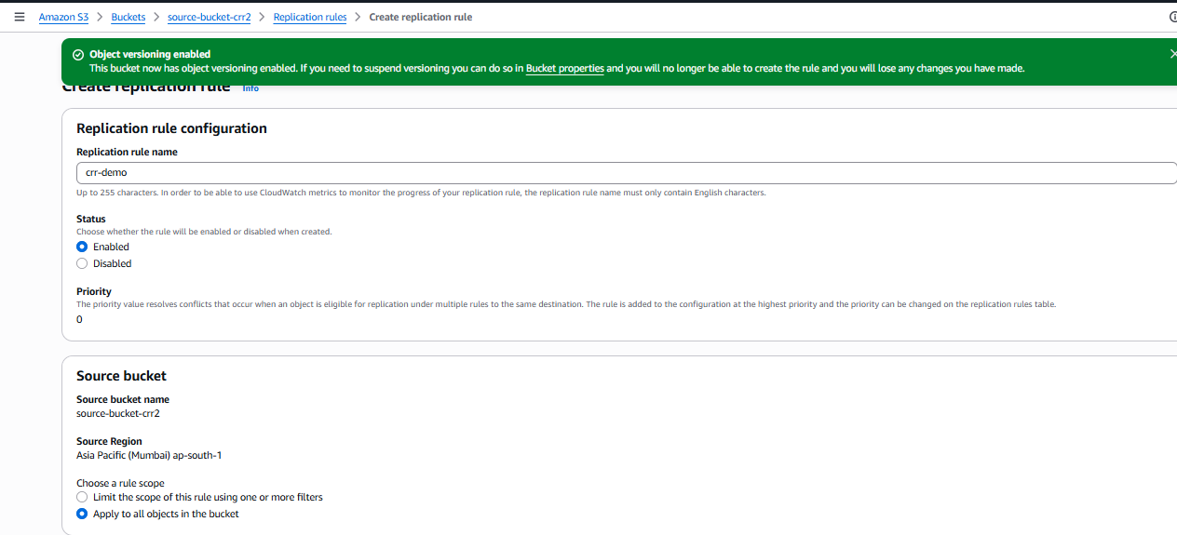

Select destination bucket
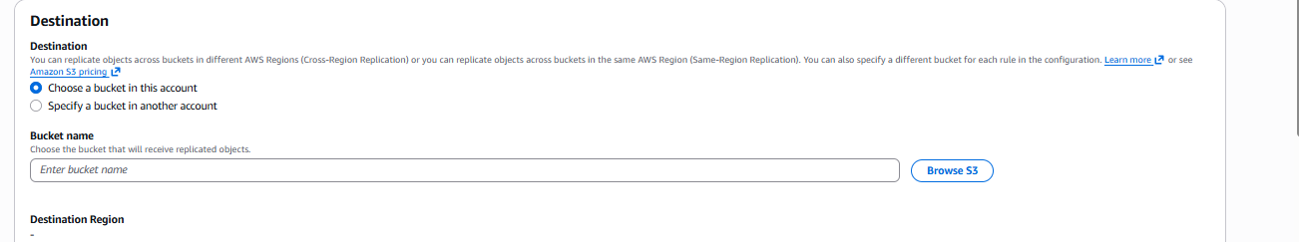

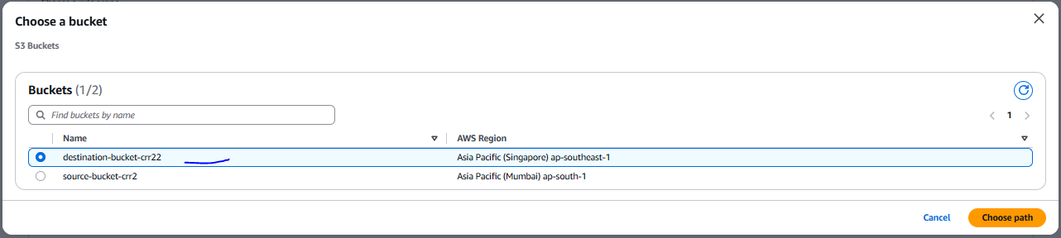

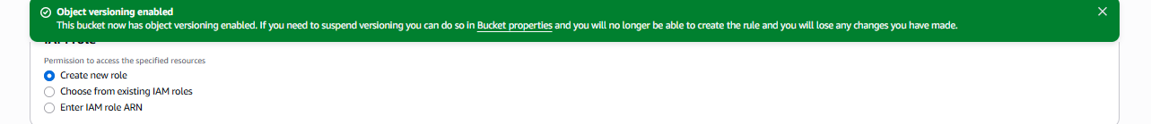
Then save
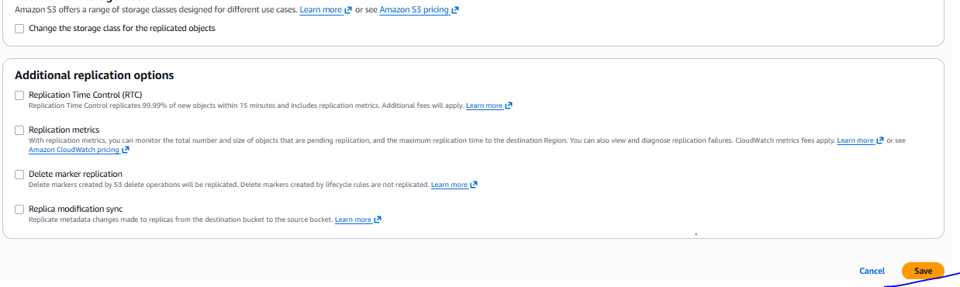
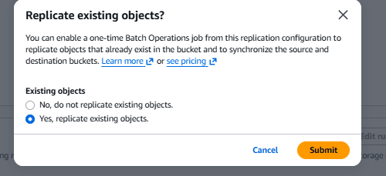
Verified
